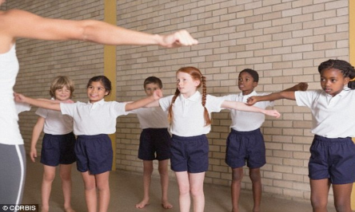
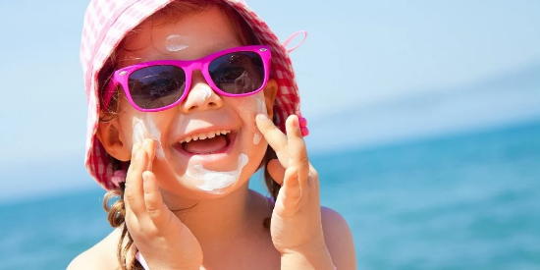

Dear Parents
As the weather is so warm the decision has been made that the children can come to school in their PE kit if they want to.
We would however like to stress that it must be the official school uniform PE kit which consists of blue or black shorts, a white T shirt or polo shirt and black pumps. (Children may also wear suitable sandals or footwear for the hot weather)
We have noticed that on PE days lots of pupils are now coming in football kits, their own shorts and t shirts and not the requested PE kits. It is still part of our uniform, and we would like to see an improvement in this.
Can we also ask that children are provided with water bottles and sunhats each day and that you apply suncream before they come to school.
As you are aware we are promoting more outdoor learning and also the children are out to play at lunchtime, so they do need to be protected.
Obviously should the weather be unsuitably warm to stay outdoors the children will be kept in the shade or indoors.
Their safety is paramount to us, and we will ensure they are hydrated throughout the day.
From tomorrow we are happy for children to come in their PE kits until further notice.
Many thanks
Mrs Stephens

