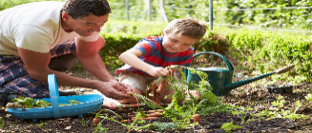
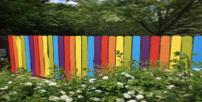

WE NEED YOUR HELP!!!!
On Friday 21st June, 2024, we are arranging a Community Day at the school. We have held these before and they proved to be beneficial to the school, fun for all involved and gave the pupils a real sense of achievement. It is a wonderful chance to bring everyone together to work for the good of all our children.
The object of the day is to improve the school grounds and update tired areas of the school that need a revamp or an update.
We ask children, teachers, parents, grandparents, governors, parishioners, and friends of the school to join us in our efforts to improve things for the pupils here at St Anne’s.
There are a variety of jobs and activities we try to sort out on these days that can be carried out by anyone of any age or with any skill.
For example, these may include the following:
Gardening, fence painting, maintenance issues, sorting and clearing the school pond, tidying the grounds in general etc.
Parents can take their child out to complete work and the pupils get so excited if their parents are able to help and take part.
We are asking for as many of you that can to turn up and help us on the day. Summer is coming and we want to make our outdoors as accessible and appealing as possible for all the children here at St Anne’s.
It is also a lovely opportunity to meet other stakeholders involved in our school.
Please consider if you can give us a few hours of your time. It can be the whole day, a few hours or just half an hour if that’s all you can spare.
Drinks and biscuits will be provided throughout the day to keep our energy levels up!!
Please let your child’s class teacher know if you are able to help us out on the day.
Thank you in anticipation!
Mrs Stephens

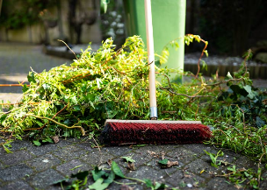
Together we can make a change!

